LSCM UNIT 4.4 MODULE 4

**PUSH AND PULL STRATEGY IN SUPPLY CHAIN MANAGEMENT**

* Push and pull strategy refers to two different approaches to managing the flow of goods in a supply chain management.
* A push strategy aims to keep products in stock even before the customer’s order them.
* A pull strategy produces goods in accordance with the demand of the customers.
* While Coca-Cola uses a push strategy, companies like Toyota use a pull strategy in supply chain management.
* There are many similarities between push and pull strategies, including their goal and need for flexibility.
* The differences between the two range from lead time to inventory management.
* In real life, most businesses like Amazon use a mix of both push and pull strategies.

Every successful business relies heavily on efficient supply chain management to run its everyday operations. Some of the most successful companies in the world, like Amazon and Walmart, rely heavily on new and sophisticated techniques in supply chain logistics to run their operations. On average, companies waste approximately 25% of their inventory due to overstocking, leading to significant financial losses. Moreover, inventory costs can consume about 15% of a company’s revenue, underscoring the importance of effective inventory management within the supply chain. So it is important to understand the concept and how you can utilize push and pull strategies un supply chain management.

Supply Chain Management (SCM) plays a pivotal role in today’s competitive business landscape. To ensure smooth operations and customer satisfaction, implementing effective strategies is crucial. Supply Chain Management refers to the coordinated activities involved in the production, procurement, storage, and distribution of goods and services from their point of origin to the end consumer. It encompasses a network of interconnected entities, including suppliers, manufacturers, logistics providers, retailers, and customers.

Implementing a push strategy allows manufacturers to streamline production schedules and allocate resources based on forecasted demand. This approach minimizes production delays and optimizes inventory management. In fact, a study by Aberdeen Group revealed that companies using a push strategy can improve customer satisfaction by up to 20%. By meeting demand promptly, businesses can enhance the overall customer experience, building loyalty and driving growth.

On the flip side, implementing a pull strategy enables companies to produce goods based on actual customer demand, reducing excess inventory and minimizing carrying costs. A study conducted by Gartner found that companies embracing the pull strategy can cut inventory costs by up to 50%. This approach provides the flexibility to respond quickly to market changes and customize products according to customer preferences. The result is Improved efficiency, reduced waste, and enhanced profitability.

**PUSH STRATEGY IN SUPPLY CHAIN MANAGEMENT**

Under the push supply chain, the logistics are driven by long-term projections of customer demand. For example, at the end of the summer season, clothing brands start to manufacture more warm clothes. This type of planning becomes valuable to companies as it helps them plan for events in the future and be prepared when winter comes. This gives the companies time to meet their needs and time to figure out other logistics like where to store the inventory.

But instead of responding to actual demand, a push strategy relies on often wrong predictions. High variable expenses, divestments, discounting, missed sales, stock shortages, high levels of debt, and rescheduled production cycles are other drawbacks of this approach.

**ADVANTAGES OF PUSH STRATEGY**

**Better Inventory Control**

A key advantage of a push strategy in a supply chain is better inventory control. Using the push strategy, manufacturers can produce products in advance, stock them, and then sell them with rising demand. This reduces the risk of stock-outs. Notably, stock-outs can lead to lost sales and customer frustration. Further, manufacturers can also reduce the risk of overstocking and related costs by using a push strategy.

**Forecasting Accuracy**

A push strategy in the supply chain helps manufacturers have a better understanding of demand patterns. Using the push strategy, manufacturers can have a more accurate view of the market. This leads to improved forecasting accuracy. Improved forecasting accuracy is crucial for effective planning and decision-making.

**Reduced Lead Time**

Another advantage of a push strategy in the supply chain is that it can reduce lead times. In this strategy, customers receive the products faster as products are produced and stocked even before the customer places an order. This can be particularly beneficial in today’s fast-moving markets where customers are looking for quick and reliable delivery.

**Alignment of Supply and Demand**

A push strategy can help align supply and demand in a better way. This reduces the risk of obsolescence. Using a push strategy in the supply chain, manufacturers can respond quickly to changes in demand and make necessary adjustments to production and inventory levels.

**Focus on Standard Products**

A push strategy in the supply chain can allow manufacturers to focus on producing standard products in high volume. This will help in reducing costs and improve efficiency. As production processes can be streamlined using a push strategy, the production of standard products will increase.

**LIMITATIONS OF PUSH STRATEGY**

**Customer Demand Variability:**

In a push strategy, products are manufactured based on forecasts and pushed into the market. However, unpredictable changes in customer demand can lead to inventory imbalances and excess stock. This challenge highlights the importance of accurate demand forecasting and the need to adapt quickly to dynamic market conditions.

**Inventory Management:**

Push strategy relies on maintaining high inventory levels to meet anticipated demand. However, this approach can result in carrying costs, product obsolescence, and the risk of stockouts. Effective inventory management techniques, such as just-in-time (JIT) inventory, can help address these challenges by minimizing holding costs and optimizing stock levels.

**Production Planning:**

Aligning production capacity with anticipated demand is a crucial aspect of push strategy. Insufficient production capacity can lead to delays and missed delivery deadlines. Implementing efficient production planning processes, such as capacity analysis and resource optimization, can enhance production capabilities and minimize bottlenecks.

**Information Sharing in the Supply Chain:**

In a push strategy, effective communication and information sharing among supply chain partners become critical. Lack of real-time data exchange and collaboration can lead to inaccurate forecasts, delayed responses, and inefficient operations. Embracing technology-driven solutions like integrated information systems and collaborative platforms can foster seamless communication and enhance overall supply chain performance.

**REAL-WORLD EXAMPLES OF PUSH STRATEGY**

* FMCG (Fast Moving Consumer Goods) companies such as Unilever and Coca-Cola use a push strategy in their supply chain management. They predict consumer demand for their products and then push their inventory to retail stores and meet the increasing demand.
* Toy manufacturing company Lego uses a push strategy very effectively. They anticipate consumer demand for certain toys during holidays and peak periods and use a push strategy in their supply chain management to produce in-demand products in high volume.
* Book publishers such as Penguin Random House, HarperCollins, and Simon & Schuster use a push strategy in their supply chain management. These publishers forecast the demand for new releases and stock their inventory in bookstores and online retailers even before the releases are available for readers to buy.

**PULL STRATEGY IN SUPPLY CHAIN MANAGEMENT**

Under the pull supply chain, the manufacturing and supply process is driven by actual customer demand. In this type of supply chain logistics, inventory is acquired on a need basis. This type of planning benefits includes less wastage in the case of lower demand. The problem, however, is that the company might not have enough inventory to meet rising demands due to unforeseen factors. For example, an auto repair shop only orders the parts it needs. In this case, the business waits until it gets an order to procure the parts required for the repair.

**ADVANTAGES OF PULL STRATEGY**

**Enhanced Customer Relationships**

Satisfied customers are the lifeline of any business. A pull strategy in supply chain management can help businesses build strong, long-lasting relationships with their customers. Businesses can use a pull strategy to demonstrate a commitment to customer satisfaction by quickly and accurately fulfilling customer demand. This can lead to increased customer loyalty and customer requisition rate.

**Dynamic Response to Customer Demand**

One of the key benefits of a pull strategy is that it allows businesses to respond dynamically to changing customer demand. This strategy helps manufacturers closely monitor customer behavior. It helps them to adjust production and delivery. Pull strategy helps businesses to survive even in a highly competitive market.

**Better Quality Control**

With a pull strategy in the supply chain, businesses can take a more hands-on approach to quality control. In a pull strategy, businesses only produce products when they are needed. This allows businesses to produce only high-quality products.

**Sustainable Supply Chain**

A pull strategy in supply chain management can help businesses reduce waste, minimize surplus inventory, and improve overall sustainability. Businesses produce products as they are needed using a pull strategy. Further, using this strategy, manufacturers can closely monitor demand and reduce their environmental impact.

**Better Resource Allocation**

A pull strategy in supply chain management can help businesses allocate their resources more effectively. Businesses using this strategy are not tied up in surplus inventory or overproduction. They can also avoid the need for large amounts of working capital to support surplus inventory. This can result in improved cash flow and resource utilization and save costs.

**LIMITATIONS OF PULL STRATEGY**

**Order Fulfillment:**

In pull strategy, products are manufactured based on actual customer demand. However, managing order fulfillment efficiently poses challenges such as lead time reduction, ensuring product availability, and minimizing stockouts. Streamlining order processing, optimizing logistics networks, and implementing robust demand-driven replenishment systems can alleviate these challenges.

**Bullwhip Effect:**

The bullwhip effect refers to the amplification of demand fluctuations as they propagate upstream in the supply chain. This phenomenon can result in excessive inventory, inefficient resource allocation, and increased costs. Employing collaborative forecasting techniques, sharing real-time sales data, and fostering strong relationships with suppliers can mitigate the bullwhip effect and improve supply chain coordination.

**Technology and Automation:**

Leveraging technology in a pull strategy can enhance visibility, enable accurate demand sensing, and automate various supply chain processes. Integration of advanced technologies like Artificial Intelligence (AI), Internet of Things (IoT), and predictive analytics can enable real-time demand monitoring, efficient order processing, and proactive inventory management.

**REAL-WORLD EXAMPLES OF PULL STRATEGY**

* Toyota is a well-known example of a company that uses a pull strategy in its supply chain management through Just-in-Time (JIT) manufacturing. Instead of producing large quantities of a product ahead of time and storing it in a warehouse, JIT manufacturing produces products only when there is an actual demand for them. This approach helps reduce inventory costs and waste. This pull strategy also helps in increasing efficiency by only producing what is needed.
* Many companies, such as UPS and FedEx, use a pull strategy in their reverse logistics operations. These companies pick up returned products from customers only after they have placed a return request. This helps to reduce the amount of unnecessary transportation and handling of returned products. Using a pull strategy here also helps in minimizing the amount of inventory that needs to be stored in a warehouse.
* Companies like Vistaprint use a pull strategy. They produce printed products, such as t-shirts and business cards, only after a customer places an order. This helps to reduce waste and the cost of maintaining a large inventory.

**COMPARISON BETWEEN PUSH AND PULL STRATEGY**

**SIMILARITIES**

Despite their differences, there are some similarities between push and pull strategies in supply chain management:

* Both push and pull strategies in supply chain management rely on data and technology to make informed decisions. For example, push strategies use data such as sales history and market trends to make forecasts. Meanwhile, pull strategies use real-time data from point-of-sale systems to respond to changes in demand.
* Both strategies require a certain level of flexibility and adaptability. In a push strategy, the supply chain must be able to quickly finish production to meet an increase in demand. On the other hand, in a pull strategy, the supply chain must be able to respond quickly to changes in demand by adjusting production accordingly.
* Both strategies focus on satisfying the end consumer. No matter if it is a push strategy or a pull strategy, the supply chain must deliver the right product to the right customer at the right time.
* Both strategies involve multiple stakeholders in the supply chain. These include suppliers, manufacturers, distributors, and retailers. Each stakeholder plays a critical role in ensuring that the products reach the customers properly.

While there are many similarities between the push and pull strategies in a supply chain, there are also several key **DIFFERENCES BETWEEN THE TWO**:

**Lead time vs. Response time**

Push strategies to have longer lead times. This is because, in this strategy, products are produced in advance based on demand forecasts. Meanwhile, pull strategies have shorter response times. In this strategy, production is adjusted quickly according to the changes in demand.

**Cost Structure**

Push strategies typically have higher upfront costs. Businesses using this strategy produce products in advance. However, businesses using the pull strategy have lower upfront costs. They adjust their production based on actual sales.

**Inventory Management**

Businesses using push strategies balance inventory levels based on demand forecasts. Meanwhile, pull strategies minimize inventory levels by only producing what is actually sold. This difference in inventory management can impact both the cost structure and the flexibility of the supply chain.

**Forecasting vs. Real-time data**

Push strategies often rely on historical data and demand forecasting to determine production levels. Meanwhile, pull strategies rely on real-time data from point-of-sale systems to determine and adjust production levels.

Amazon is one of the world’s biggest online retailers, managing billions of dollars worth of inventory each year. Push and Pull logistics are a big part of their inventory management. Amazon’s warehouses are strategically placed, moving closer and closer to main metropolitan areas and city centers. As a result, it uses a pure push strategy for the products it stores in its warehouses based on the downstream demand forecast. On the other hand, it uses a pure pull strategy when it sells products from third-party sellers to minimize its own risk for unsold inventory.

**Conclusion**

In real life, no businesses rely entirely on either push or pull logistics but instead employ a mixture of the two to make the best use of them. Modern-day supply chain operations are very complex and consist of steps from getting the raw materials to delivering the final product to the end consumer.

**DELL’S SUPPLY CHAIN STRATEGY**

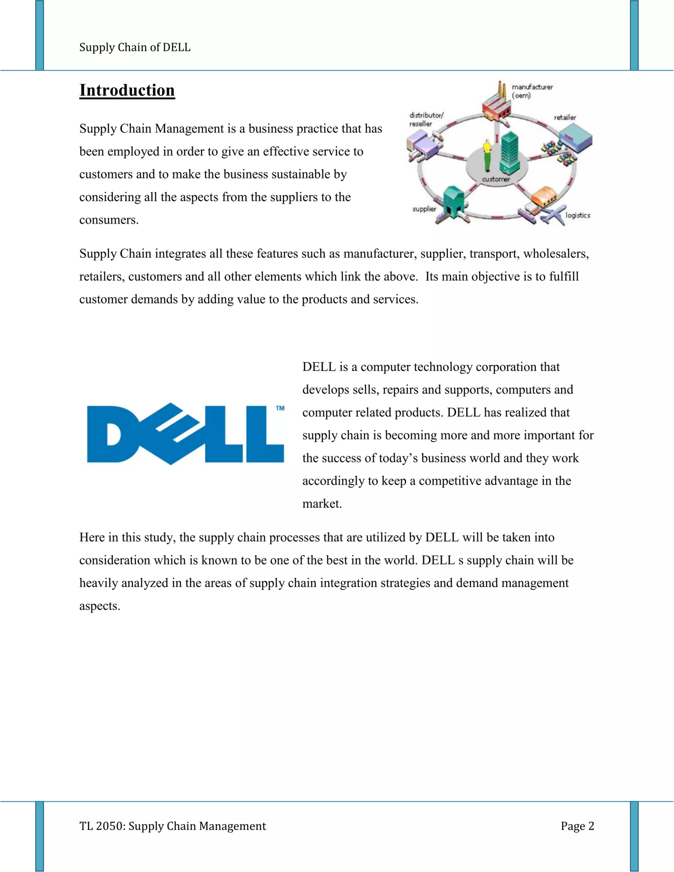

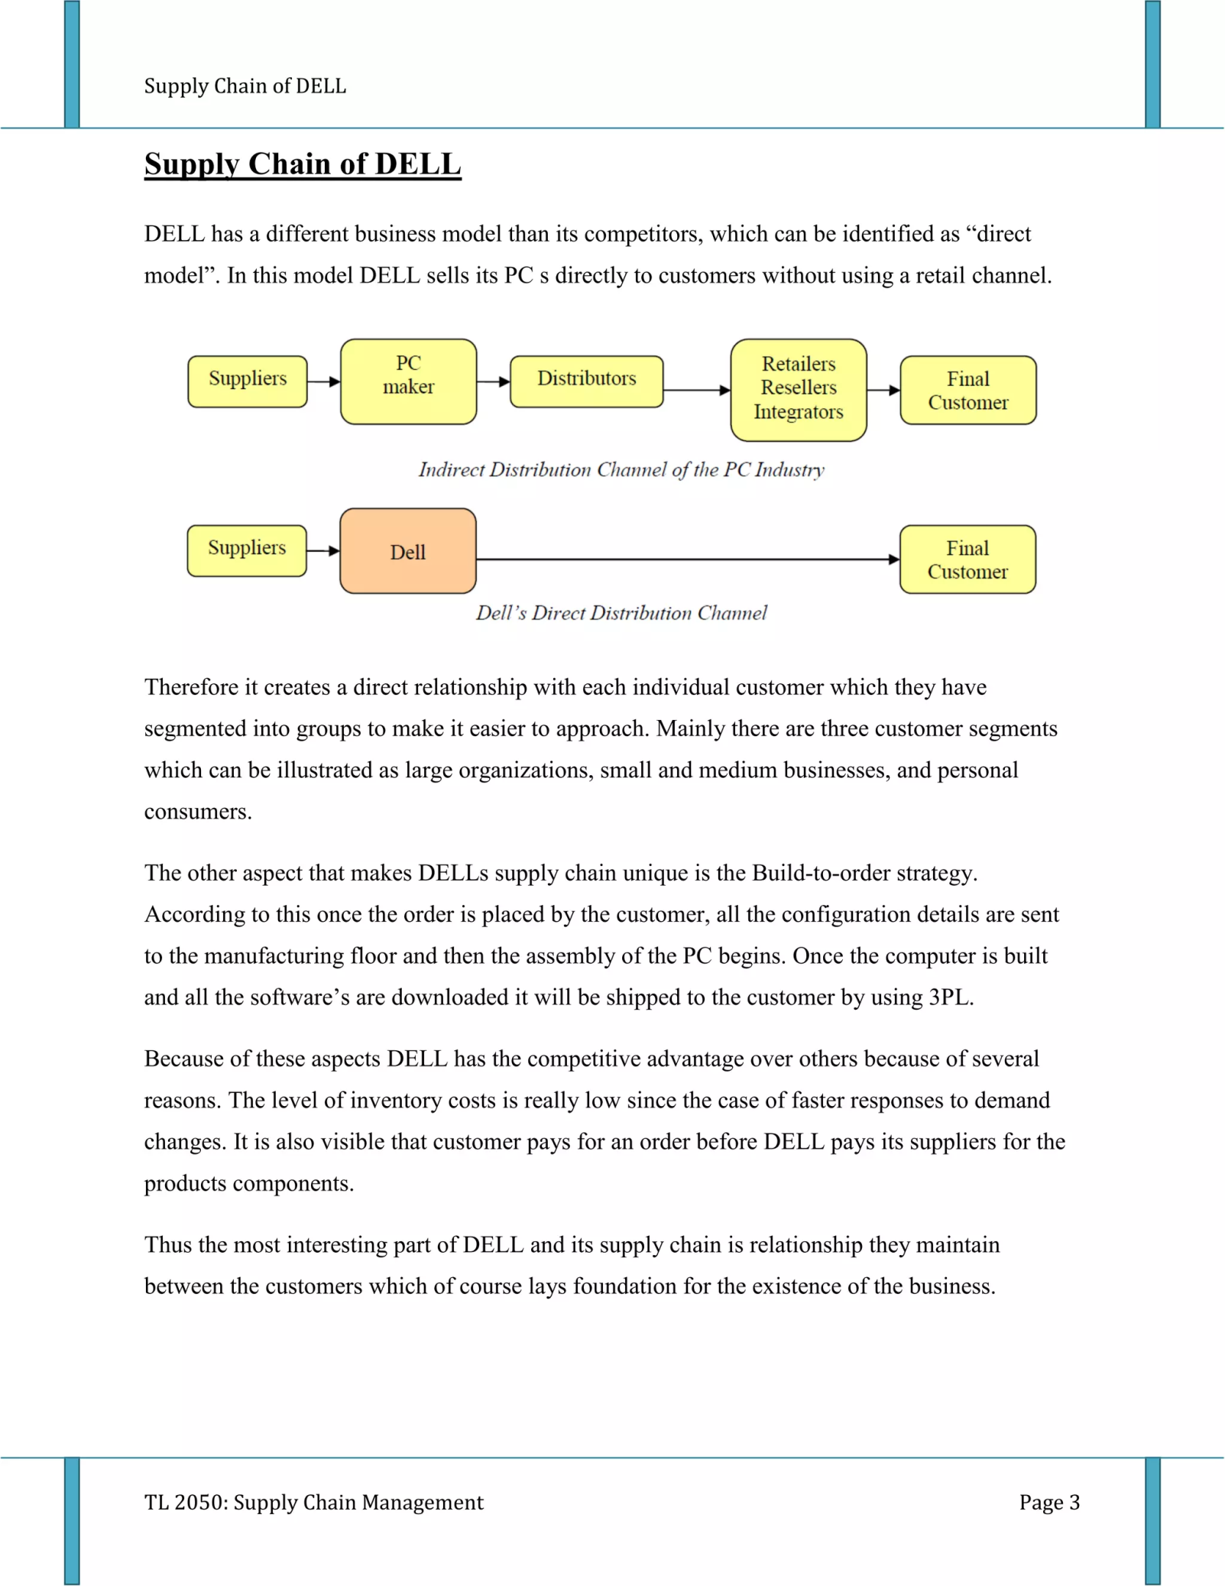

Dell is a multinational computer technology company that designs, develops, and sells personal computers, servers, data storage devices, network switches, software, and other technology-related products and services. Dell’s business model is based on two key elements: its efficient supply chain and its innovative marketing strategy.

**Supply Chain Strategy of Dell**

Dell’s supply chain strategy is based on a direct sales model, which allows the company to maintain tight control over its supply chain and reduce costs by eliminating intermediaries. The critical and essential elements of Dell’s supply chain strategy include:

* 1. **Build-to-Order Manufacturing**: Dell’s manufacturing process is based on a build-to-order model, which means that the company only produces products after receiving customer orders. This approach enables Dell to keep inventory levels low and avoid overproduction, which can result in excess inventory and higher costs.
  2. **Lean Inventory Management**: Dell’s lean inventory management system ensures that the company maintains low inventory levels while still meeting customer demand. Dell achieves this by maintaining close relationships with its suppliers channel partners and implementing vendor-managed inventory (VMI) systems.
  3. **Direct Sales Model**: Dell’s direct sales model is a key component of its supply chain strategy. Dell can eliminate intermediaries such as wholesalers, retailers, and distributors by selling directly to customers. This approach helps to reduce costs and improve the speed of delivery.
  4. **Just-In-Time Manufacturing:** Dell’s manufacturing process is based on the just-in-time (JIT) concept, which means that the company only produces products when there is a customer order. This approach helps to minimize excess inventory and reduces the risk of obsolescence.
  5. **Supply Chain Collaboration:** Dell works closely with its suppliers to ensure that it has the right parts at the right time. This collaboration helps improve the supply chain’s speed and efficiency, reduce lead times, and minimize costs.
  6. **Customization:** Dell’s ability to offer a high degree of customization to its customers is a significant competitive advantage. By allowing customers to tailor their products to their specific needs, Dell is able to offer a unique value proposition that sets it apart from competitors.
  7. **Brand Recognition:** Dell’s brand recognition is a significant competitive advantage. The company has built a strong, brand image and reputation over the years, which has helped it to establish a loyal customer base, market, and gain a competitive edge in the market.
  8. **Innovation:** Dell’s focus on innovation is another competitive advantage. The company has a strong research and development team that is constantly working on new technologies and products. By staying at the forefront of technological innovation, Dell is able to offer cutting-edge products and services that set it apart from competitors.
  9. **Cost Efficiency:** Dell’s cost efficiency is a significant competitive advantage. The company’s lean inventory management system, just-in-time manufacturing process, and efficient supply chain enable it to keep costs low and offer competitive prices to customers.
  10. **Segmentation:** Dell segments its own market share based on a variety of factors, including demographics, psychographics, and behavior. The company’s primary customer segments include small and medium-sized businesses, large enterprises, and individual consumers. Within each of these segments, Dell further segments based on factors such as age, income, job title, and location.
  11. Targeting: Dell’s targeting strategy focuses on identifying its target customers’ specific needs and preferences and tailoring its products and services accordingly. For example, Dell offers a range of customizable products and services designed specifically for the small business, and medium-sized businesses, such as servers, storage solutions, and networking products. Similarly, Dell targets large enterprises with high-end products and services that can meet their complex and diverse technology needs.
  12. **Positioning:** Dell’s positioning strategy is focused on differentiation. The company positions itself as a technology leader that offers cutting-edge products and services designed to meet the specific needs of its own target market and customers in emerging markets. For example, Dell’s high-end gaming laptops are positioned as the ultimate gaming machines, while its business-focused products are positioned as reliable and efficient tools for boosting productivity.
  13. **Strategic Partnerships**: Dell has formed strategic partnerships with other companies in the technology industry, such as Intel and Microsoft. These partnerships help to strengthen Dell’s brand and provide it attract potential customers with access to the latest technology and innovations.
  14. **Customer Service:** Dell places a strong emphasis on customer service and support. The company offers a range of customer support services, including technical support, warranty and repair services, and online forums and communities where customers can share their experiences and get help from other customers.
  15. **Digital Marketing:** Dell’s digital marketing efforts include targeted online ads, search engine optimization, and social media campaigns. The company also uses email marketing to communicate directly with customers and offer exclusive promotions and deals.
  16. **Event Sponsorship**: Dell often sponsors and participates in technology-related events and conferences to promote its products and services. This includes events such as CES (Consumer Electronics Show), Dell Technologies World, and other industry-specific events.
  17. **Product Launches:** Dell promotes its new products through targeted advertising campaigns and launch events. The company often partners with influencers and thought leaders in the technology industry to create buzz and generate excitement around its new products.

Dell’s supply chain strategy focuses on efficiency, reducing costs, and meeting customer demand. By adopting a build-to-order manufacturing approach, maintaining lean inventory levels, and selling directly to customers, Dell has built a highly efficient and cost effective supply chain that has helped drive the company’s success. Dell’s marketing strategy has differed from its competitors in several ways, including its direct sales model, focus on customization, targeted advertising, and emphasis on the overall customer experience. These differences have helped differentiate Dell from its competitors and build a strong brand reputation.